H.T No
Regulations:
A20

Sreenidhi Institute of Science and Technology
(An Autonomous Institution)
Code No: 8KC81 Date: 18-Jan-2023 (FN)

B.Tech III-Year I- Semester External Examination, January-2023 (Regular)
STRUCTURAL ANALYSIS (CIVIL)

Time: 3 Hours Max.Marks:70

Note: a) No additional answer sheets will be provided.
b) All sub-parts of a question must be answered at one place only, otherwise it will not be valued.
c) Missing data can be assumed suitably.
Bloom's Cognitive Levels of Learning (BCLL)

Remember | L1 | Apply | L3 | Evaluate | L5
Understand | L2 | Analyze | L4 | Create | L6

Part - A Max.Marks:20

Answer all QUESTIONS.

 |  | BCLL | CO(s) | Marks
1 | Define Static and Kinematic Indeterminacy. | L1 | CO1 | [2M]
2 | Draw Shear force diagram for a fixed beam carrying an uniformly varying load of 0 to w kN/m. | L1 | CO2 | [2M]
3 | Write the slope deflection equations for a two span continuous beam? | L1 | CO3 | [2M]
4 | What is meant by distribution factor? | L1 | CO4 | [2M]
5 | Write the advantages of Kani’s method? | L1 | CO5 | [2M]
6 | What is meant moving load or rolling load? | L1 | CO6 | [2M]
7 | What is the fixed end moment of a uniform beam of span ‘L’ fixed at the ends, subjected to a central point load ‘P’. | L1 | CO2 | [2M]
8 | How do you account for sway in slope deflection method for portal frames? | L1 | CO3 | [2M]
9 | List out the characteristic of influence line diagram. | L1 | CO6 | [2M]
10 | What is carry over moment? | L1 | CO5 | [2M]

Part – B Max.Marks:50
ANSWER ANY FIVE QUESTIONS. EACH QUESTION CARRIES 10 MARKS.

 |  |  | BCLL | CO(s) | Marks
11. |  | A cantilever of length 10 m carries an UDL of 3 kN/m over the entire span. The free end of the cantilever is supported on a prop. Two concentrated loads of 30kN and 50kN acts on the beam at a distance of 3m and 5m from the fixed end. Draw the shear force and bending moment diagram. | L4 | CO1 | [10M]
12. |  | A fixed beam AB, 5m long, carries a point load of 48kN at its center. The moment of inertia of the beam is 5x10⁷ mm⁴ and value of E for the beam materials is 2x10⁵ N/mm². Determine fixed end moments at A and B, and deflection under the load. | L4 | CO2 | [10M]
13. |  | A continuous beam hinged at left end carries the load as shown in figure. Determine the bending moments and reactions at all supports using slope deflection method.  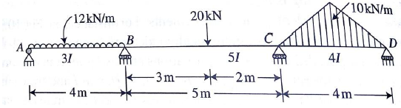 | L4 | CO3 | [10M]
14. |  | Using moment distribution method, determine the end moments in the continuous beam as shown in the figure.  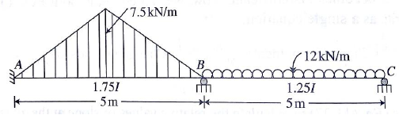 | L4 | CO4 | [10M]
15. |  | Analyze the continuous beam shown in figure by Kani’s method and sketch the B.M.D.  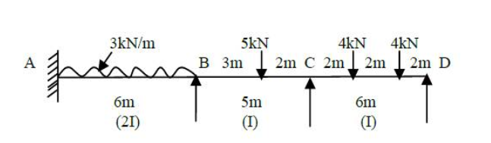 | L4 | CO5 | [10M]
16. |  | A S.S beam with a system of moving loads is shown in the figure below, calculate the absolute maximum bending moment and shear force.  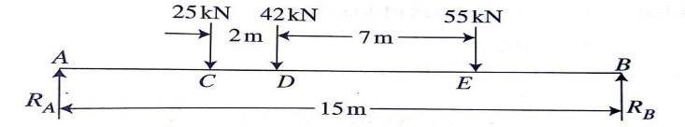 | L4 | CO6 | [10M]
17. |  | A continuous beam consists of three successive span of 8 m, 10 m, 6 m, and carries loads of 6 kN/m, 4 kN/m, 8 kN/m respectively on the spans. Using slope deflection method analyze the beam and draw the bending moment diagram. | L4 | CO3 | [10M]
18. |  | Analyse the continuous beam shown in figure using moment distribution method  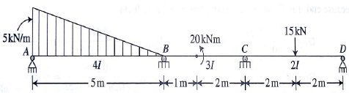 | L4 | CO4 | [10M]

-- 00 -- 00 –

